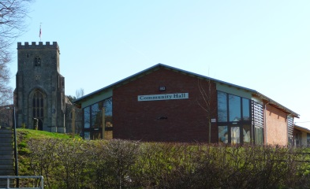 | MARKET LAVINGTON COMMUNITY HALL MANAGEMENT TRUST  Registered Charity No 1049118  FOR OUR VILLAGE | 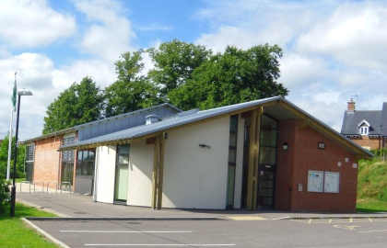

Market Lavington Community Hall opened in October 2007. It is situated at the centre of our community and, as a fully licensed, fully air conditioned premises, with underfloor heating, it is an ideal venue for weddings, parties, concerts and other special occasions.  The Hall is now also equipped with and a superb wall mounted projector in the main hall, with free Wi-Fi connection and DVD/Blu-ray player, so is even more of an ideal venue for Training and Conferences as well. |  | The main hall holds approximately 160 people seated or 250 people standing. The Furminger Room is a smaller round room, ideal for meetings or training sessions for up to 25 people.  The venue is very well equipped with a modern kitchen and bar, excellent disabled access and ample parking.  The location of Market Lavington in the centre of Wiltshire means that the venue is easily accessible to the whole county.

Regular Activities currently held include:

Weekly Activities | Sessions |  | Contact | Telephone Number
Short Mat Bowls | Monday Tuesday Wednesday | 10.30am  2.00pm  7.30pm | Derek Moore | 01380 813266
Tai Chi | Monday | 6.30pm | Andy Wright | 07811 910214
Yoga | Monday | 7.30pm | Ann Vingoe | 01380 870233
Dancing Class | Tuesday | 7.45pm | Louise Cambourne | 07917 573831
Keep Fit | Wednesday | 6.15pm | Claire Ballardie | 01380 812483
Art | Thursday | 9.30am | Wendy Trinder | 01380 812258
Community Choir | Thursday | 8.15pm | Jo Morton | 01380 816441
Table Tennis | Thursday | 6.00pm | Andy Saunders | 01380 818242
Trinity Church | Sunday | 10.30am | Rev. Gary Gotham | 01380 724264
Monthly Activities | Sessions |  | Contact | Telephone Number
Monday Club | 1st & 3rd Monday | 2.00pm | Liz Francis | 01380 812249
Kennet Quilters | 2nd Monday | 1.30pm | Aileen Farmer | 01380 813486
Fishing Club | 1st Monday | 8.00pm | Tony Allen | 01225 752541
Women’s Institute | 2nd Tuesday | 7.30pm | Pat Morrison | 01380 812357
Film Club | Saturday/Sunday | 3pm or 7.30pm | Sue Stone | 01380 812636

For Bookings: Jackie Clark 01380 816523 marketlavingtoncommunityhall@hotmail.com
Visit our website: www.mlch.co.uk

